Refactoring CRUD Application with MVC Architecture and Blade Templates

In this workshop, you will refactor your existing Student List CRUD application (from Week 6) to follow the MVC architectural pattern and implement the Blade templating engine.

PART 1: Setup
- Create a new project inside your htdocs folder. Follow the given directory structure:
workshop8/
├── app/
│ ├── controllers/
│ ├── models/
│ └── views/
│ └── layouts/
├── public/
├── cache/
└── views/

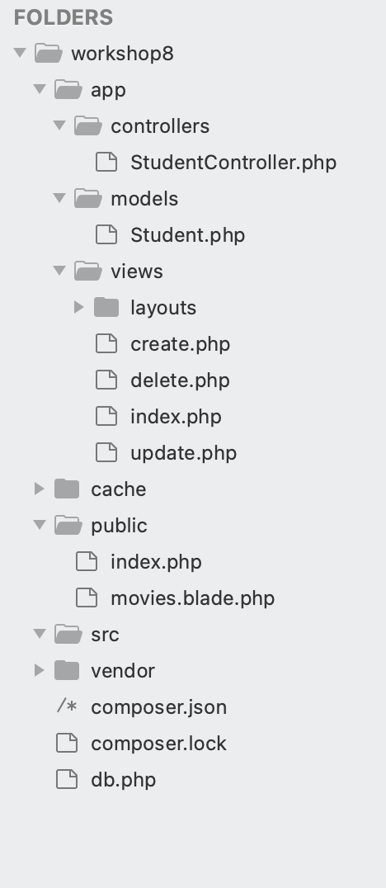
- Place your database connection file (db.php) in the project root directory (Inside workshop8 folder). Use same code as workshop 6 (connection to same school_db database as done in workshop 6)
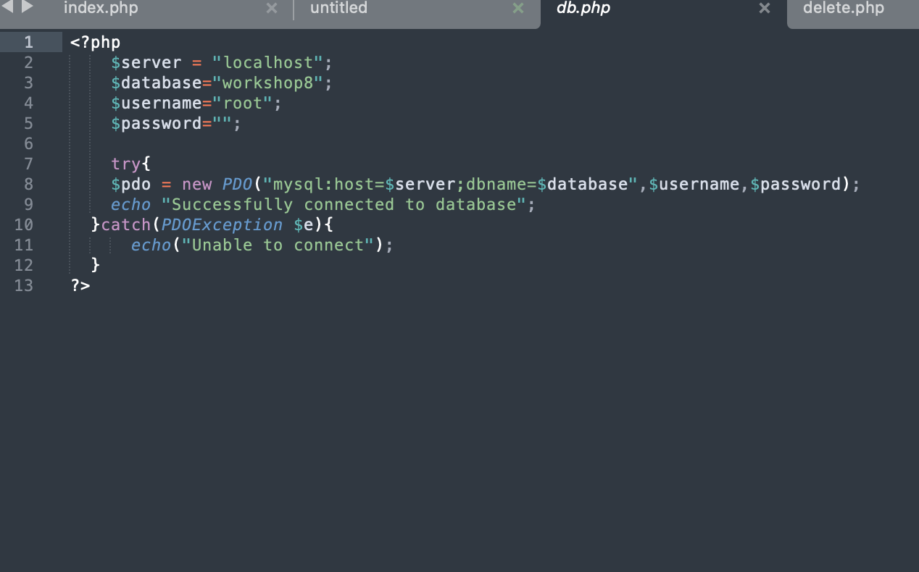

PART 2: Using Template Engine

Install Composer : https://getcomposer.org/download/

Use PHP installed in c:/xampp/php/php.exe (for Windows)

- Open your terminal/command prompt and navigate to your project root directory (Inside workshop8 folder).
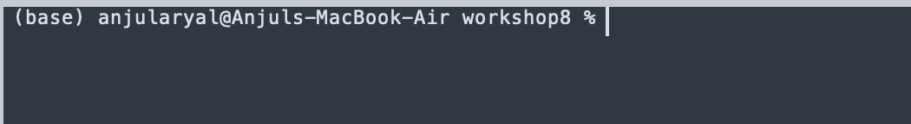

- Initialize Composer using this command:
composer init
Follow the prompts, keep all settings as default

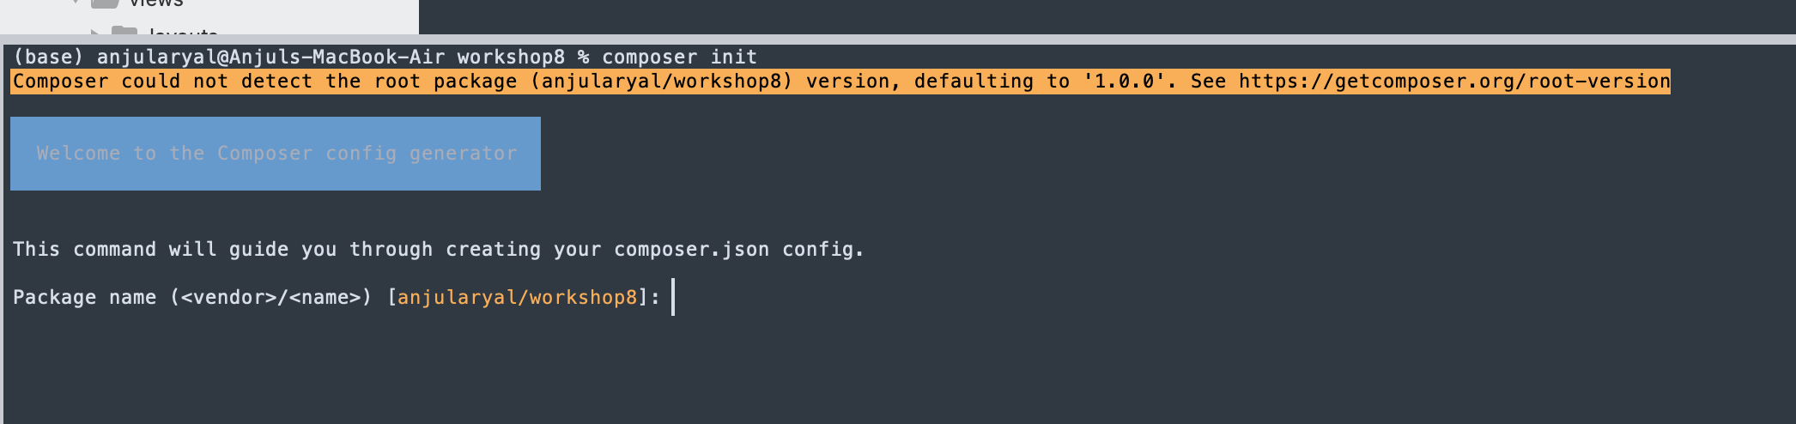
- Install the Blade template engine using Composer:
composer require jenssegers/blade
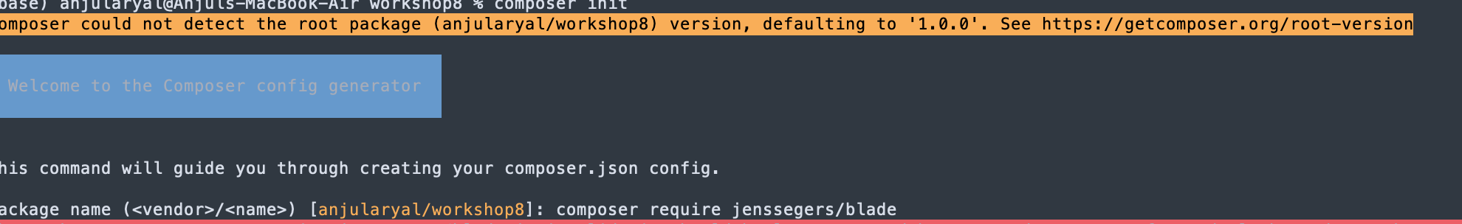

Your folder structure should now look like this. All the composer and template specific files are added inside the vendor folder.
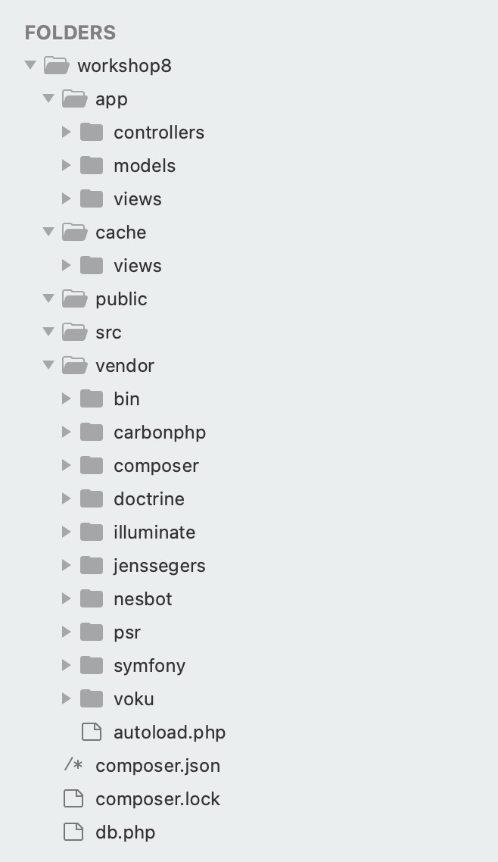

PART 3: Creating the Model

- Create a file app/models/Student.php that will contain the Student class.

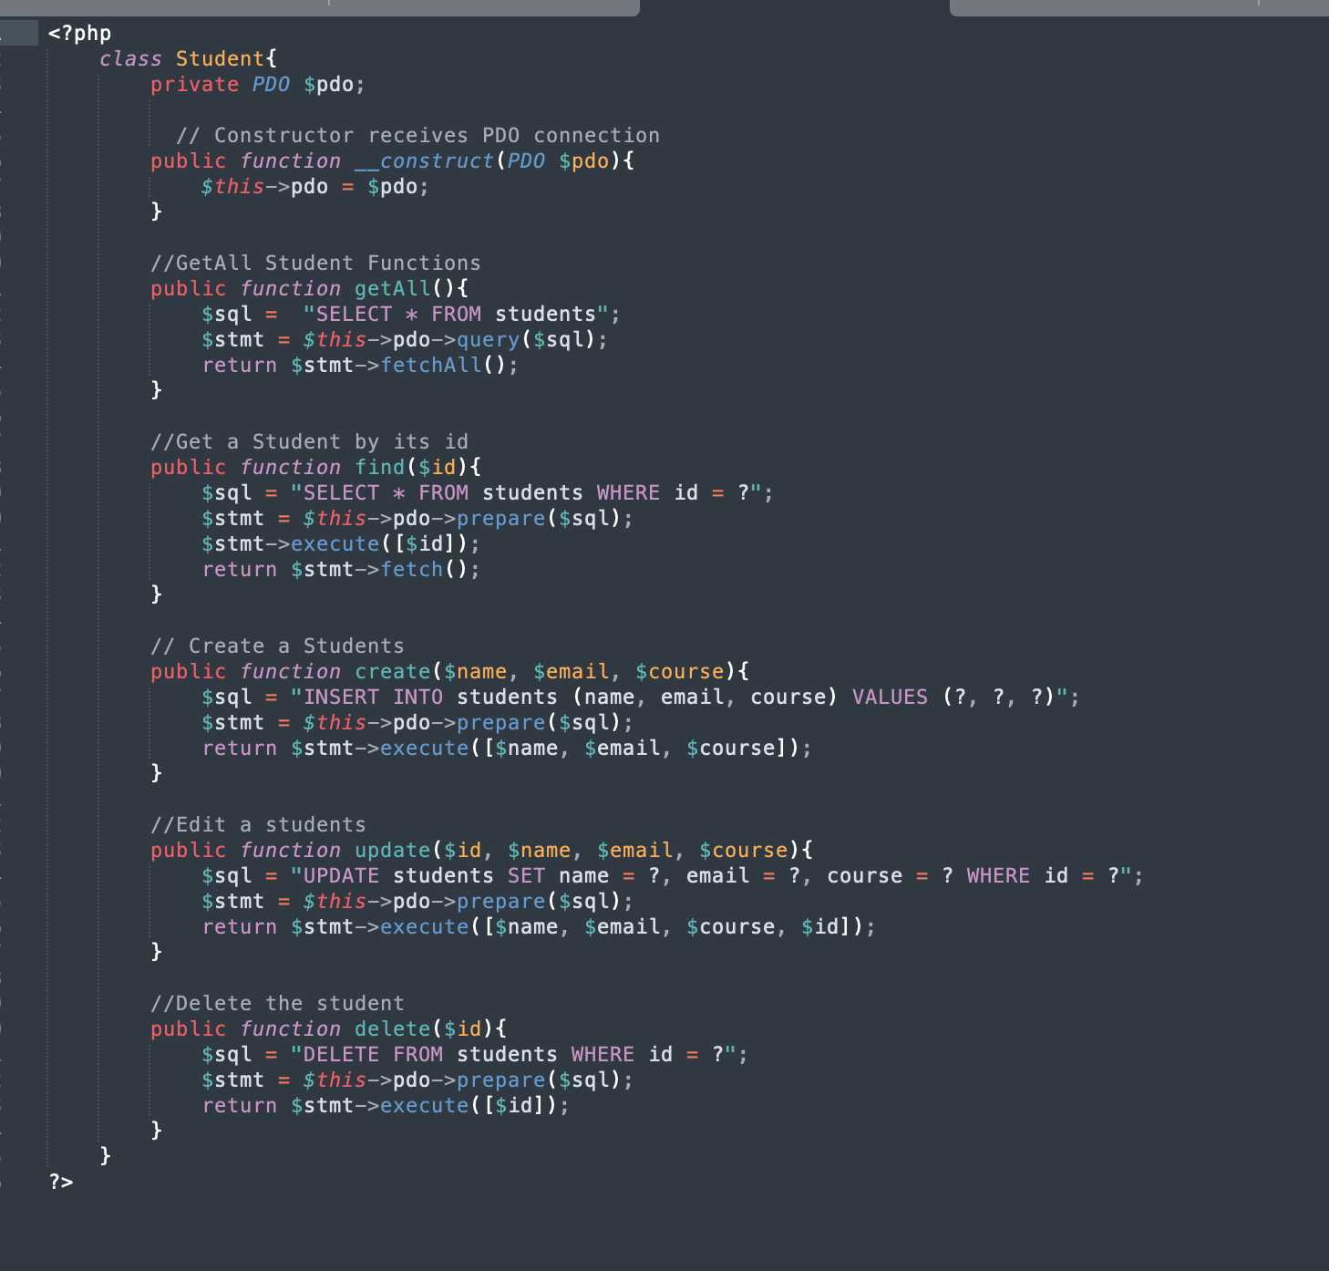
- Implement methods for all CRUD operations:

  - all() to retrieve all students
  - find($id) to retrieve a single student by ID
  - create($name, $email, $course) to insert a new student
  - update($id, $name, $email, $course) to update an existing student
  - delete($id) to remove a student record

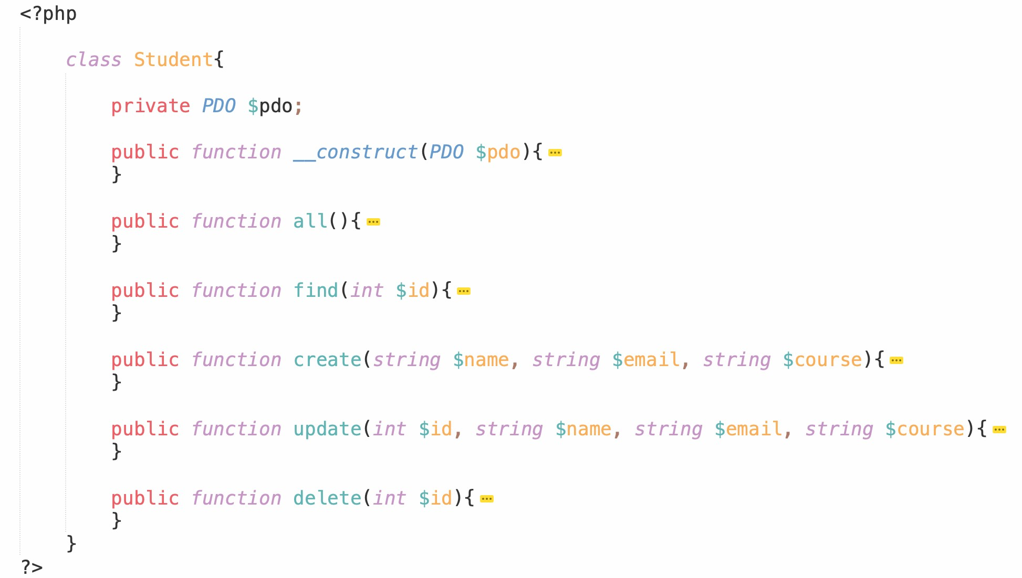


PART 4: Creating the Controller

- Create a file app/controllers/StudentController.php that will contain the
StudentController class.
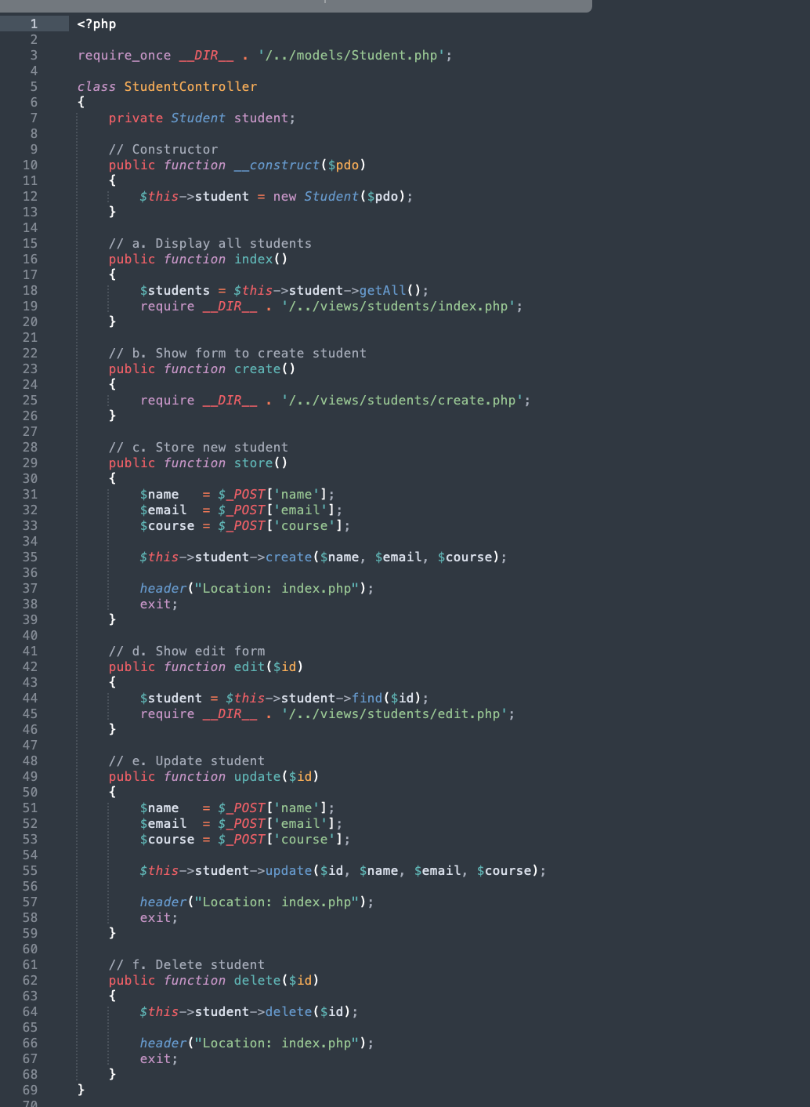

- Implement the following methods in your controller:

  - index() to display all students
  - create() to show the form for adding a new student
  - store() to process the form submission for adding a student
  - edit($id) to show the form for editing an existing student
  - update($id) to process the form submission for updating a student
  - delete($id) to remove a student record



PART 5: Setting Up Blade and Routing

- Create the main entry point file public/index.php.

- Set up the Blade engine by specifying the paths to your views and cache directories.

Eg:

<?php
require __DIR__ . '/../vendor/autoload.php';
use Jenssegers\Blade\Blade;

$views = __DIR__ . '/../app/views';
$cache = __DIR__ . '/../cache/views';

$blade = new Blade($views, $cache);

?>

- Implement a simple routing system that:

a. Reads the requested page from the URL parameters

b. Instantiates the StudentController with dependencies
c. Calls the appropriate controller method based on the requested page
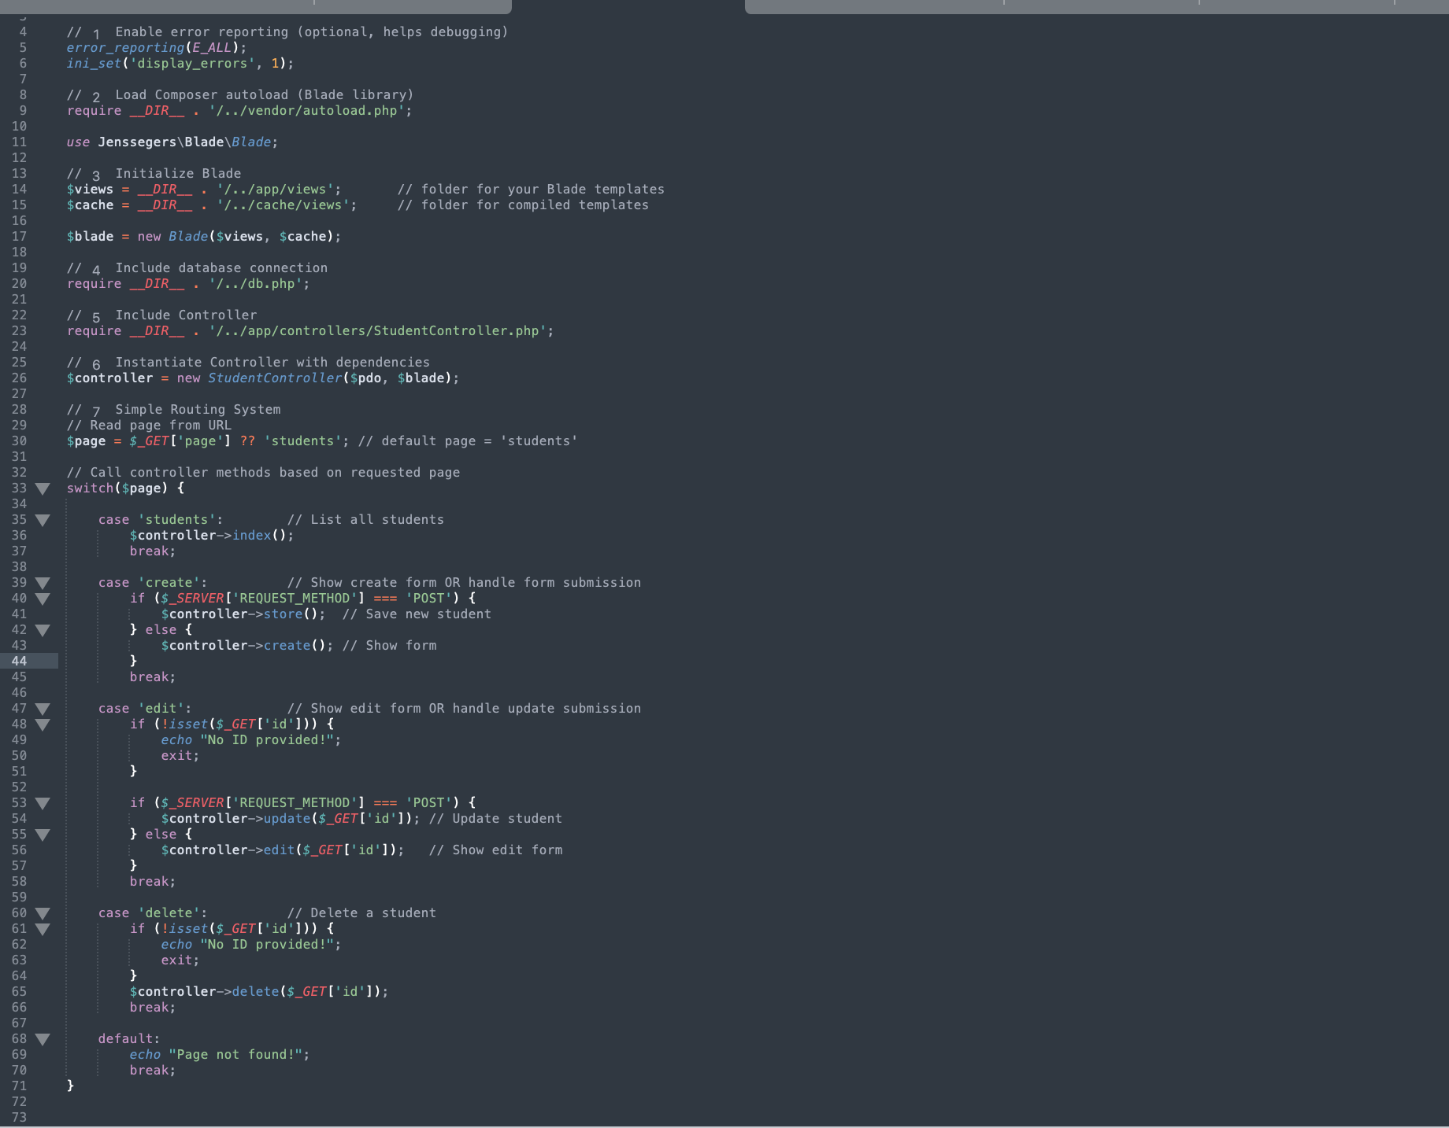
4. If you get version error while navigating to index.php through localhost

- Open composer.json file that’s located in the root directory, then make changes to the versions of php and blade so that they align with each other.
You can use these recommended versions.

{
"require": {
"php": ">=8.0",
"jenssegers/blade": "^1.4"
}
}

- Update composer using terminal in your root directory. Run:

composer update

PART 6: Creating Blade Views

- Create a master layout file app/views/layouts/master.blade.php that contains:

  - HTML structure (head, body)
  - CSS styling for your application
  - @yield('content') directive to define where child views will inject content

- Create the following views that extend the master layout:

  - app/views/students/index.blade.php: Student list with actions (edit/delete) and a link to add a new student
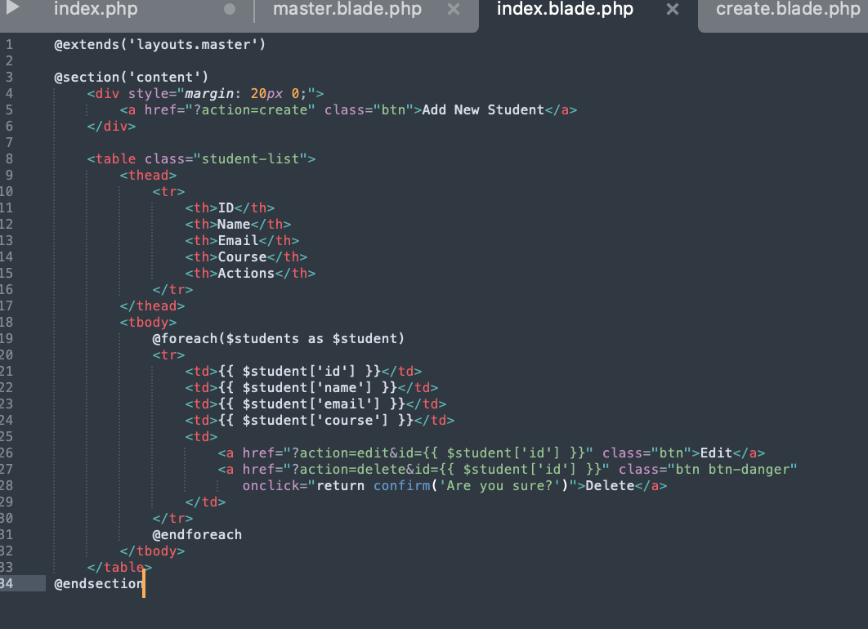

app/views/students/create.blade.php: Form to add a new student
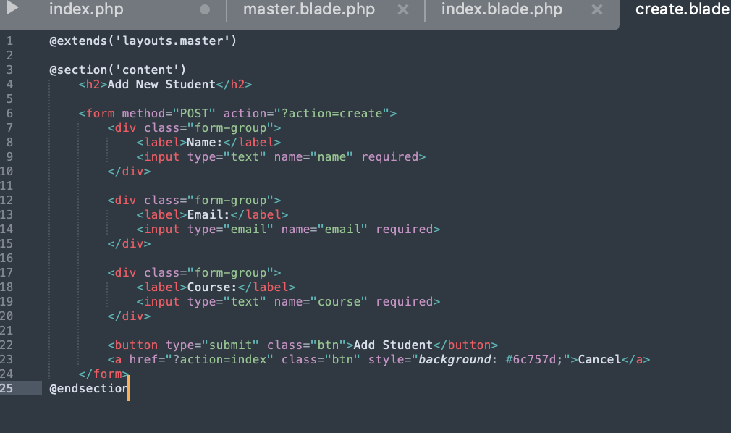

app/views/students/edit.blade.php: Form to edit an existing student

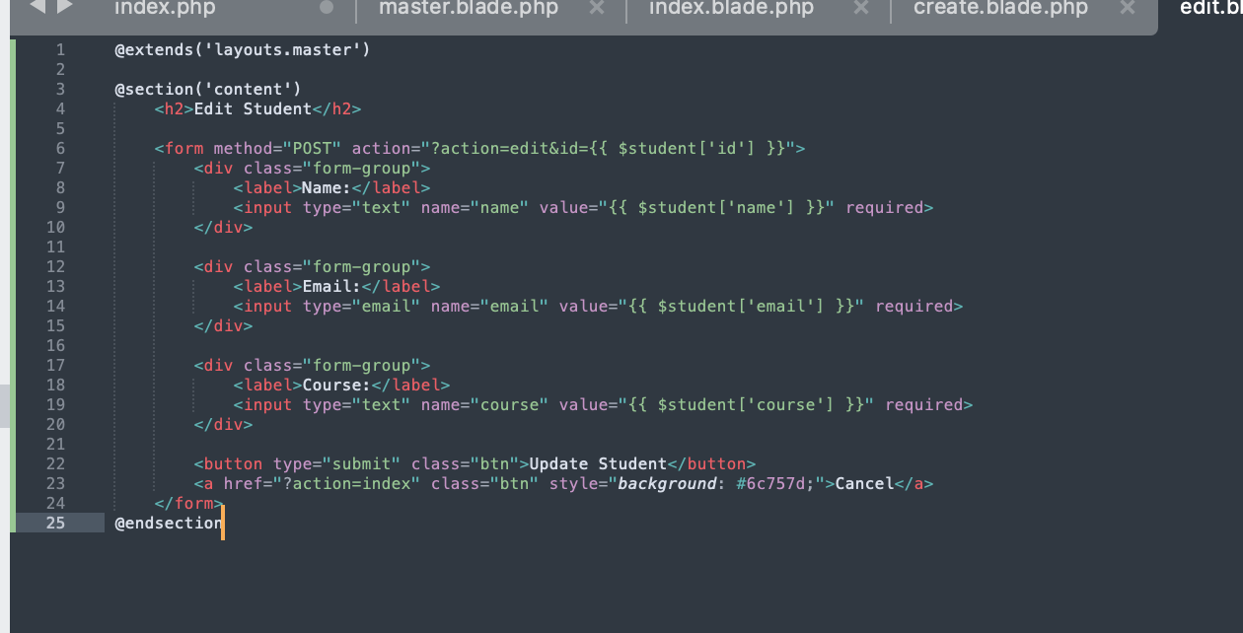
3. Use Blade syntax features:

- @extends to inherit from the master layout
- @section and @endsection to define content sections
- {{ }} to display data
- @foreach for looping through student records
- @if, @else, @endif for conditional logic

